THE KYRGYZ REPUBLIC
BRANCH OF OJSC
“POWER PLANTS” – “BISHKEKTEPLOSET”

Heating supply improvement project
THIRD START-UP FACILITY (from planned ТК up to CK-B-9)

Project Implementation Unit

PROJECT

«Heating Supply Improvement»

Tree Inventory Report

«Replacement and Reconstruction of “Vostok” main heating network
I, III and IV start-up facilities»

Environmental and Social Consultant

Kanybek Zhumaliev

Bishkek-2023
TABLE OF CONTENT

1. Background 3
2. Sub-project description. 3
3. Methodology 4
3.1 Size of tree 5
3.2 Assessment of the condition 5
3.3 Observations 5
4. Construction management 9
5. Construction impact assessment 9
6. Measures to mitigate environmental impacts 10
Appendix 1. Location of trees 11
Appendix 2. List of trees inventory participants 12
Appendix 3. Quote from a contract for construction works 13
Appendix 4. Photographs of the tree inventory 14

Bishkek - 2023

1. Background

Heating supply improvement Project (HSIP) in the Kyrgyz Republic (KR) financed by the World Bank (WB) aims to improve effectiveness and quality of heating supply in the project target areas:
(1) improving the reliability and efficiency of the district heating system (DHS) in Bishkek,
(2) improving energy efficiency of public buildings.

Direct Executors of the HSIP are OJSC “Electric Power Plants” (EPP)) for Component 1 and the Community Development and Investment Agency (ARIS) for Component 2.
The implementation of the HSIP will favorably affect the proposed project facilities by improving the efficiency and quality of heating energy supply for heating and hot water supply.

The HSIP Project is categorized as Category B for both anticipated environmental and social impacts based on the type, location, sensitivity, scope, nature and extent of potential adverse environmental and social impacts.

This tree inventory report has been prepared for the "Replacement and Reconstruction of “Vostok” main heating network, I, III, and IV Start-Up Facilities". As a result of the WB mission, which took place from October 10 to October 13, 2023, it was recommended to conduct an inventory of trees for the “Vostok” network and submit the results to the Bank. Based on the above, BTS prepared a report on the inventory of trees for the “Replacement and reconstruction of “Vostok” main network, I, III, and IV start-up facilities” within the framework of component 1 “Increasing the reliability of heating supply and the performance of the district heating system.” The purpose of conducting a tree inventory is to record the species, size and condition of trees on the right-of-way, assess the expected impact of a proposed reconstruction, and provide more detailed information to assist in the conservation of trees during project implementation.

2. Sub-project description.

Component 1: Improvement of reliability of heating supply and productivity of the DH system
Executing Agency: Branch of OJSC “Power Plants” – “Bishkekteploset”
Place of sub-project implementation: Bishkek city
Estimated period of the construction works: 2023-2024
Type of activity: Reconstruction
Types of planned activities within the framework of the subproject: “Replacement and reconstruction of “Vostok” main heating network, I, III, IV start-up facilities"

Design and estimate documentation (DED) was prepared for the subproject by the “Seureca” design company.

The design and estimate documentation was approved by the Chui - Bishkek Territorial Administration of the State Agency for Environmental Protection and Forestry under the Government of the Kyrgyz Republic on November 21, 2018 and by the State Expertise Department of the State Agency for Architecture, Construction and Housing and Communal Services under the Government of the Kyrgyz Republic on July 23, 2020. The design and estimate documentation was revised and approved in 2022 due to rising prices for construction materials, which was approved at an extended meeting of the General Directorate of the branch of OJSC “Power Plants” – “Bishkekteploset” on April 22, 2022. There have been no technical changes related to the location, length and right-of-way of the planned network.
The length and diameter of the pipelines that will be installed at the Sites of the “Vostok” subproject are shown in Table 1 below.

Table 1. Length of start-up facilities to be reconstructed

№ | Name of start-up facility | Location | Length | Diameter of pipelines, mm
 |  |  |  | Existing | To be installed
1 | Ist start-up facility | СК-В-3а to СК-В-4 | 326 m | 2 Dn 700 mm | 2 Dn 900 mm
2 | IIIrd start-up facility | Thermal chamber to СК-В-9  Thermal chamber CK-B-9 to Thermal chamber CK-B-8 | 755 m  500 m | 2 Dn 700 mm  2 Dn 700 mm | 3 Dn 900 mm  2 Dn 200 mm  (overground pipeline)
3 | IVth start-up facility | СК-В-9 to НС 4 | 745 m | 2 Dn 700 mm | 2 Dn 900 mm
 | TOTAL |  | 2 326 m

3. Methodology

On November 30, 2023, a commission consisting of the design company, the company’s technical supervision, BTS engineers and PIU specialists visited the site. The trees were identified, counted, measured and assessed for condition. An inventory and assessment of trees was carried out, containing the name, quantity, diameter, etc.
The discovered trees were not opened, and excavations for a detailed examination of the root crown were not carried out. A visual inspection of the above-ground parts of each tree was carried out. Because some symptoms may only be present seasonally, the scope of observations may be limited by the time of year in which the tree inventory was taken.
Because trees are living organisms, their health and vitality constantly change over time due to seasonal fluctuations, changes in site conditions, and a number of other factors. For this reason, the assessment provided in this report is valid at the time of inspection and no guarantee is made as to the continued health of trees considered to be in good condition. It is recommended that trees be re-evaluated periodically to identify changes in their condition. While every tree has the potential to fail and therefore poses some risk, a tree's score is a good indicator of current health and potential problems that may arise in the future.
The master plan indicates the number and location of trees (Appendix 1).

3.1 Size of tree

Size refers to the diameter of the trunk, measured in centimeters at a height of 1.3 m above the ground (chest level). If trees have more than one trunk from the base, the size of each trunk is recorded separately.
The size of smaller trees and shrubs is given as an approximate height.

3.2 Assessment of the condition

The trees were given a subjective condition rating: Excellent, Good, Satisfactory, Unsatisfactory, and Dead. Below is a brief description of how the rating is determined:

Table 2. Assessment of trees condition

Excellent | There are no obvious health problems; good structural form;
Good | Minor health and/or structural problems;
Satisfactory | More serious health and/or structural problems;
Unsatisfactory | Serious health and/or structural problems;
Dead | Dead tree.

3.3 Observations

Some structural defects are included in the “Notes” section of the Tree Inventory and Assessment Table. Structural defects are often minor when the tree is small, but can create problems when the tree gets larger and the weight of the branches puts additional stress on the defects which can cause weakness. Larger trees can also cause more damage if they fail.

Below is an explanation of some of the problems and how they can affect tree health over time.

- Girdling roots are roots that intersect with each other or around the tree trunk. As these roots grow larger, they can limit nutrient and water uptake and prevent structural anchorage.

- Involved bark is bark that has penetrated the crotch at the junction of the limbs and causes weakening of the attachments of the branches. As the diameter of the trunk and branch increases, the bark of each stem in the tight crotch begins to move apart, increasing the likelihood of failure.

- Narrow branch angles, especially where there is bark, can become a problem as trees grow larger because the inner wood is poorly attached.

- Codominant leaders (2 trunks or branches of approximately the same size) often have narrow branch angles and are associated with weak branch attachments. Strong branch attachments occur between two branches of different sizes, with sufficient space for branches to expand and form a ridge of branch bark.

- When a tree has multiple branches from the same point of attachment, they usually have the characteristics of loosely attached branches.

- Crossing branches are often associated with narrow branch angles. Branches that cross each other often rub, causing damage and therefore weakness to one or both branches, and crossing branches can end up encircling each other.

- Depressed areas under forest branches are often a sign of internal decomposition.

- Sapsucker holes are holes in the trunk or branches made by birds in search of insects. This damage is a sign of insects on the tree and can make trees more susceptible to other infections.

- A leaning tree may be more susceptible to wind loads and soil erosion. Self-correcting tilt refers to the natural correction of tilt through the development of new growths that counteract the tilt of the torso, providing a more balanced form.

- Dieback refers to the death of the ends of branches and is often associated with root problems.

- The antler effect refers to dead branches protruding from the crown of a tree, and often indicates a state of significant decline.

- Vines growing over tree crowns suppress energy and eventually kill trees by blocking sunlight. They also add weight, which can make trees more vulnerable to breakage during storms.

- Witches' broom is a dense mass of shoots that are stunted and may look like a clump of twigs (or a witch's broom). This may be caused by unfavorable environmental conditions, such as road salt that kills the top buds, or by insect or disease problems.

Ist Start-up Facility

Work on the reconstruction of the section of "Vostok" main heating network will be carried out from CK-B-3a to CK-B-4 (Dostoevsky St.), according to the design and estimate documentation. The route diagram of Ist start-up facility can be found in Appendix 1.

Planned construction commencement date is March 2023, planned construction completion date is October 2023. The length of the route is 326 m.

On the section from CK-B-3a to CK-B-3, it is planned to replace the over-ground laying, on the section from CK-B-3 to CK-B-4 it is planned to dismantle all existing pipelines and to install new 2 DN900 mm pipelines, as well as to carry out the reconstruction of CK-B-4.

On the section from CK-B-3a to CK-B-3 with a length of 180 m, an overground laying of a heating network is foreseen in polyurethane foam insulation with a galvanized sheath and leakage detection system. . Heat pipelines are laid on sliding supports. Pre-insulated pipes - steel pipes GOST 30732-2006 with thermal insulation made of polyurethane foam and with a protective galvanized sheath. Dismantling and installation of 1 DN 200mm steam line shall be done.

On the section from CK-B-3 to CK-B-4 with the length of 146 m heat pipelines 2 DN920x10 are foreseen and laid on the designed sliding supports instead of the dismantled 2 DN 700 mm pipelines of the heating network, which are laid separately in the existing passage channel, under the railway tracks. All existing DN500, PP-5 DN 500, KP DN200, VPZ PS DN700, VPZ OS DN700 pipelines in the passage channel are subject to dismantling.

On the southern side of the CK-B-3a, at the nearest fixed support, the installation of 2 DN 900 mm sectional valves is designed, then on the south side of 2 DN 900 mm designed valves, 2 DN 500 m jumpers are installed with the installation of shut-off valves between the designed 2 DN 900 mm heating networks in polyurethane foam insulation and the existing pipelines. The designed heat pipelines are laid on sliding supports. To empty the pipelines of the designed heating network, the drainage devices are provided at the lowest points along the profile with output to collecting wells.
An inventory of trees for section I of the start-up facility is not required, since the site is located in an industrial zone and there are no tree plantations.

IIIrd start-up facility

The planned construction commencement date is March 2023, the planned completion date is December 2023. The length of the route is 1255 m. The route diagram of IIIrd start-up facility can be found in Appendix 1.

From the planned TK (an approximate landmark is the cross of Puteprovodnaya and 7th April streets) to the south along 7th April st. to CK-B-9 (an approximate landmark is 7th April St., turn to the building of the International University of Kyrgyzstan) to replace existing pipelines 2Dn 700 mm by 3Dn 900 mm with foam polyurethane insulation in reinforced concrete trays.

From CK-B-9 thermal chamber (an approximate landmark is 7th April St., turn to the building of the International University of Kyrgyzstan) to the east to the CK-B-8 (an approximate landmark is Oktyabrskaya st.) the pipelines Dn 200 mm with the length of 500 m of supply and return systems are to be laid for connecting existing consumers.

In CK-B-2 and CK-B-9 thermal chambers (an approximate landmark is 7th April St., turn to the building of the International University of Kyrgyzstan), existing consumers shall be switched from the reconstructed heat network. At the same time, adoption of decisions on the placement of pipelines and its marks on the profile shall be ensured.
Work performance will be guided by SNiP 3.02.01-87 "Civil works, basis and foundations".

Before the commencement of civil works, representatives of the construction organization, together with representatives of the Client will check the correctness of the breakdown of the heating pipeline by seizure in nature and draw up an appropriate act with the attachment of breakdown schemes.

Trenching for laying pipelines is carried out on the basis of a geodetic alignment scheme, longitudinal and transverse profiles. Anchoring the axis of the route is carried out with milestones driven into the ground after 10 m on straight lines and 5 m on curved sections, as well as at the turning angles of the route.

Table 3 3. Inventory of trees on IIIrd start-up facility

№ | Type of tree | Diameter, (cm) | Condition | Location from the axis of the heating main (right/left/m) | Remark
1 | Poplar | 11 | good | Right side, 2 m
2 | Poplar | 10 | good | Right side, 2 m | Leaning tree
3 | Poplar | 16 | good | Left side, 3 m

A total of 3 trees were identified from the inventory at this site to be cut down because they are above the mainline.

After the construction works, the uprooted trees will be replaced with saplings at the rate of 3 to 1.

IVth start-up facility

Works on reconstruction of the section of the main heating network "Vostok" will be carried out from CK-B-9 (approximate landmark - 7 April street, turn to the building of the International University of Kyrgyzstan) to HC-4 (approximate landmark - pump station).

The planned construction commencement date is March 2024, the planned completion date is December 2024. The length is 745 m.

The contracting company, based on its capabilities, will develop the site in full, simultaneously or in parts. The route diagram of the IV start-up facility can be found in Appendix 1.

At the section it is provided for carrying out the reconstruction of CK-B-9 and then from CK-B -9 to the south to CK-B-13 to lay underground pipeline of the heating network of 2Dn-900mm in polyurethane foam insulation in reinforced concrete trays.

From CK-B-13 built a respective transfer existing pipelines of 2Dn-700 mm to one 1Dn-900mm being designed.

From CK-B-13 to CK-B-14 replace pipelines of 2Dn-900 mm and 1Dn900 mm by 3Dn900 mm in polyurethane foam insulation in reinforced concrete trays.

To carry out the reconstruction of CK-B-14 with installation of sectioning valves 2 Dn900 mm in it with transfer in 1Dn1000mm (Supply system) pipeline and 1 valve of Dn900 mm on pipeline of Dn900mm (Return system) with the following re-laying of existing pipelines from CK-B-14 to HC №4 (approximate landmark – pump station) with 1 Dn1000 mm and 1Dn900 mm in reinforced concrete trays.
In CK-B-9а, CK-B-11, CK-B-13 and CK-B -14. Existing consumers shall be reconnected to reconstructed heating network.

Metering units shall be installed in pavilions between CK-B-13 and CK-B-14 without narrowing the pipeline diameter. The length of the route is 745 m.

Table 4. Inventory of trees on IVth start-up facilityе

№ | Type of tree | Diameter, (cm) | Condition | Location from the axis of the heating main (right/left/m) | Remark
1 | Poplar | 10 | good | Right side, 2 m
2 | Elm | 15 | good | Right side, 2 m
3 | Elm | 12 | good | Right side, 2 m
4 | Elm | 15 | good | Right side, 2 m
5 | Elm | 11 | good | Right side, 2 m
6 | Elm | 11 | good | Left side, 3 m
7 | Elm | 11 | good | Right side, 2 m
8 | Elm | 12 | good | Right side, 2 m
9 | Elm | 15 | good | Left side, 3 m

A total of 9 trees were identified by the inventory results at this site to be cut down because they are above the mainline.

After the construction works, the uprooted trees will be replaced with saplings at the rate of 3 to 1.

4. Construction management

The most typical construction damage to trees is root damage due to compaction and detachment. Although it is commonly thought that the tree's crown drip line is associated with the root area, in fact root zones can extend well beyond the tree's drip line, sometimes 2 or 3 times the height of the tree.
Slope changes and construction activities that can cause soil compaction should be kept as far away from trees as possible to protect trees. If the roots will be damaged by excavating equipment, it is best to carefully cut the roots with sharp pruning tools rather than allowing them to be torn up by large equipment. Clean cuts will help minimize rotting and disease entry points.
Equipment and materials should not be stored near trees and equipment should not be left idling if exhaust fumes could burn foliage.
Consideration shall also be given to the impact of construction on the likelihood of tree failure, such as whether roots will be affected or whether removal of neighboring trees will make the tree left behind more susceptible to wind loads.

5. Construction impact assessment

During construction activities, all measures will be taken to minimize impacts to trees.

Where construction boundaries will be close to existing trees, it is recommended that tree protection fencing be installed to ensure that root zone damage is limited and/or minimized.

It is recommended that new trees be planted along the right-of-way where space permits. Tree species should be identical to those that were present prior to construction activities.

6. Measures to mitigate environmental impacts

During construction activities, all measures will be taken to minimize environmental impacts.

In tree removal, there are a number of strategies that can be utilized to reduce environmental impacts.
For example, the use of skilled tradespeople and specialized equipment to minimize environmental impacts, including on vegetation and soil. In addition, limiting the size of the cleared area and using selective removal techniques can help preserve natural habitat and minimize disturbance to the local ecosystem.

All cut/ uprooted trees will be rehabilitated and saplings will be re-planted at a rate of 3 to 1.

The cut/rooted trees will be transferred to the “BishkekZelenkhoz” ME.
Planting saplings is also an important step in mitigating tree removal. New trees can help offset the environmental impacts of removing existing trees and restore natural habitat. It is important to carefully select seedling species that are well suited to the local climate and soil conditions.
The planting of saplings will be coordinated with the “BishkekZelenkhoz” ME.
Public engagement also plays an important role in promoting responsible tree removal practices.
Public engagement also plays an important role in promoting responsible tree removal practices.
Raising awareness of the environmental impacts of tree removal and the importance of preserving natural habitat can help to create a culture of responsible land use and promote sustainable development practices.

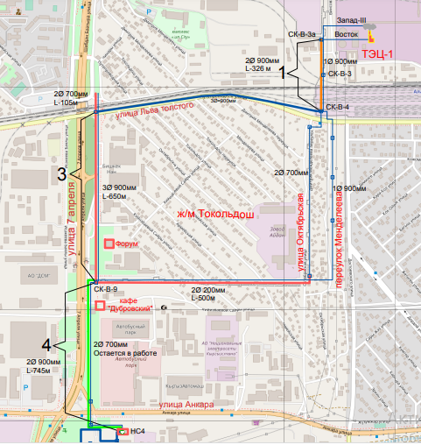
Appendix 1. Location of trees

Appendix 2. List of trees inventory participants

№ | Name | Position | Contact details
1 | Ryspaev К.К. | Manager of the Capital construction Dpt., BTS | 0 555 44 08 04
2 | Sharshenaliev U.A. | Dty. Manager of the Capital construction Dpt., BTS | 0 550 28 38 90
3 | Kanagatov A.S. | PIU Manager, BTS | 0 555 00 51 64
4 | Zhumaliev K. | Environmental and Social Consultant | 0 505 98 10 66
5 | Kasymov А. | «Seureca» Design company | 0 552 65 10 65
6 | Kulya L.L. | Gorproject under PoA from «Seureca» | 0 559 78 13 37
7 | Orozbaev N.A. | Technical supervision | 0 555 50 65 00
8 | Umetaliev J.U. | Technical supervision | 0 559 23 86 23
9 | Azatbekov B.A. | Foreman, “Technotop” LLC | 0 772 50 26 62
10 | Ignatenko V.G. | Chief Engineer, “Technotop” LLC | 0 770 83 70 08
11 | L. Pin | Representative of China Road | 0 552 10 66 08
12 | Myktar A.S.. | Designer, China Road | 0 554 10 58 85

Prepared by:

Zhumaliev К.
Environmental and social Consultant
30.11.2023.

Appendix 3. Quote from a contract for construction works

“Procurement of works for reconstruction of Vostok heating network, section from CK-B-3a to HC No.4 (start-up facilities I, III, IV)
IDA/HSIP/ICB/W/2022

- Bid documentation, part 2,Works requirements
When carrying out construction and installation works, environmental safeguards and requirements of the national legislation and regulations and requirements of the ESMP.
Requirements of SNiP 3.05.03 Environmental protection shall be met when laying out heating networks. Heating network construction is not allowed without permit obtained according to established procedure. Washing of pipelines with reused water shall be implemented. Water from washing (disinfecting) pipelines shall be discharged into areas set forth in Work performance plan.
Upon completion of heating network installation, the area shall be cleaned from construction debris and refurbished as required by the design. PU foam and PE thermal insulation debris shall be collected for further transportation and disposal in areas approved by State Sanitary and Epidemiological Supervision in accordance with procedure of toxic industrial waste accumulation, transportation and disposal.

- Bid documentation, Appendix А to the Financial part

Items included in the statements should cover the work, related equipment and materials, associated costs for transportation, storage, disposal, labor (including applicable social security and Medicare), insurance, any possible costs associated with cramped city conditions for the work, other costs - as applicable to each item.
Financing facilities are subject to value added tax in accordance with the tax code.

Appendix 4. Photographs of the tree inventory
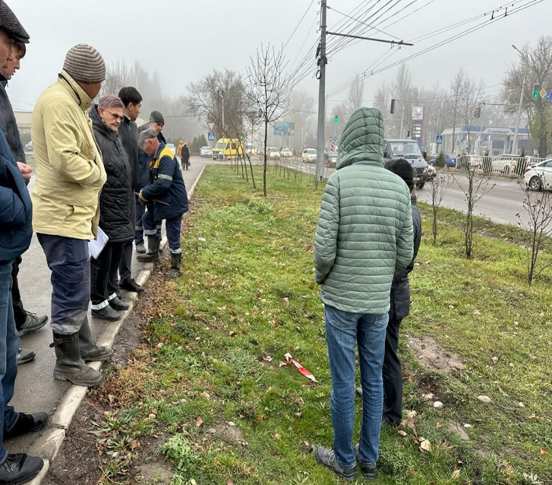
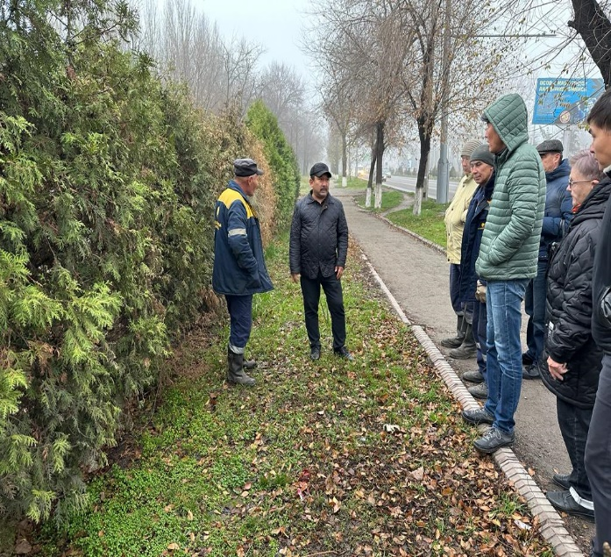
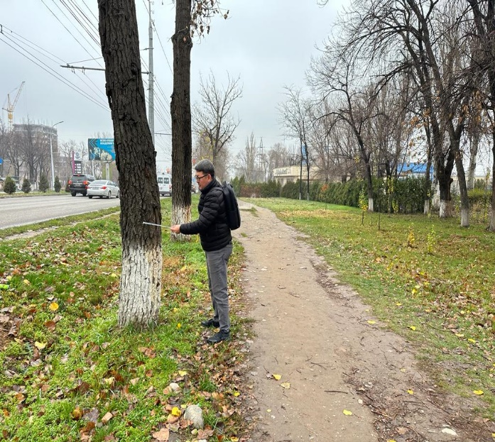
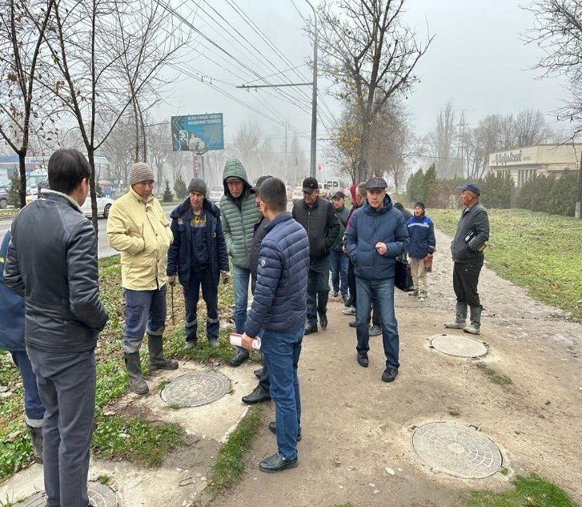
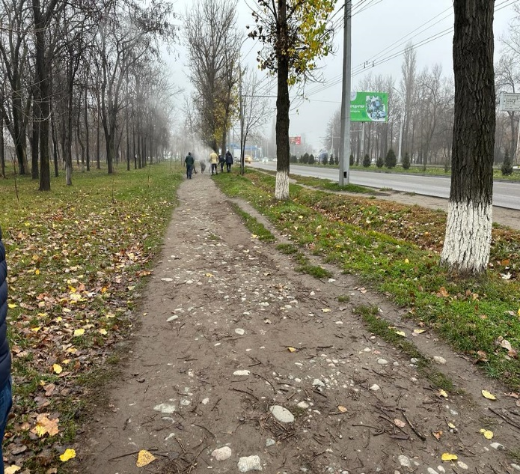
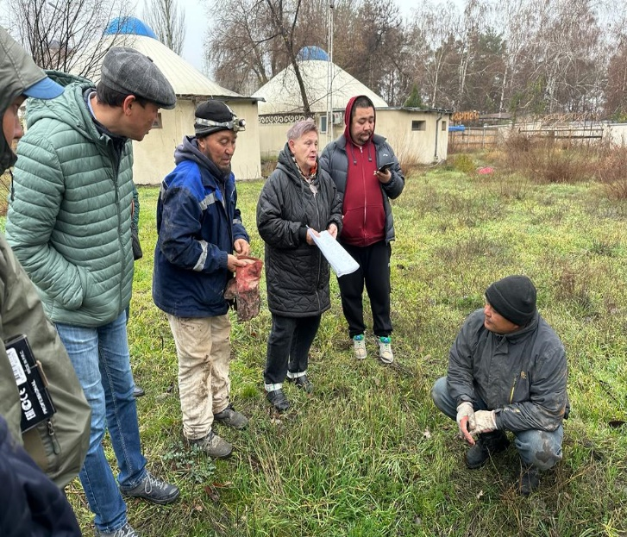

In July 2022, OJSC "Bishkekteploset" (BTS) was merged with JSC "Electric Power Plants" (EPP), with “EPP” becoming the successor of all obligations of BTS under the "Financing Agreement", "Subsidiary Agreement" and "Project Agreement" for the Heat Supply Improvement Project.

