KYRGYZ REPUBLIC

OPEN JOINT STOCK COMPANY

“Electric Power Plants”

Project Implementation Unit

“Bishkekteploset”

PROJECT

“Heat Supply Improvement”

Social Due Diligence Report for the subproject

Replacement and reconstruction of section of “Vostok” main heat network.
I, III, and IV start-up facilities

Environmental and Social Consultant

Kanybek Jumaliev

Bishkek, 2023

LIST OF CONTENT

ABBREVIATION 3
DEFINITIONS 4
Introduction 5
1. Description of the subproject 7
2. Legal framework 10
3. Screening of potential social impacts 11
4. Detailed Screening results by site 11
5. Establishment of the cut-off date 14
6. Impact mitigation measures 14
7. Information disclosure and consultations 15
8. Grievance Redress Mechanism 16
9. Monitoring and reporting 18
10. Conclusion and recommendations 18

Appendix 1. Layout of “Vostok” main network 20
Appendix 2. Date of commissioning of the "Vostok" main heating network 21
Appendix 3. Checklist of the social impact 22
Appendix 4. Technological agreements 23
Appendix 5. Extract from the contract for construction 25
Appendix 6. Screening photos 26
Appendix 7. Operational norms 29
Appendix 8. Summary of individual consultations 30

ABBREVIATION

ARIS Community Development and Investment Agency

BTS “Bishkekteploset”

CL Condensate line

DED Design estimate documentation

Dn Nominal diameter

EIZ East industrial zone

EPP Electric Power Plants

ESMF Environmental and Social Management framework

ESMP Environmental and Social Management Plan

GOST State standard

GRM Grievance redress mechanism

GS Gas station

IUK International University of Kyrgyzstan

ОP Operational policy

PAP Person affected by the project

PIU Project implementation unit

PUF Polyurethane foam

RN Return network

RPF Resettlement policy framework

SDD Social Due Diligence

SEA/SH Sexual exploitation and abuse/Sexual harassment

SN Supply network

SNiP Construction norms and rules

SP Steam pipeline

WB World Bank

DEFINITIONS

Involuntary  resettlement | The involuntary taking of land resulting in direct or indirect economic  and social impacts caused by:  a) Loss of benefits from use of such land;  b) relocation or loss of shelter;  c) loss of assets or access to assets; or  d) loss of income sources or means of livelihood, whether or not the PAP has moved to another location.
Census | A complete count of the population affected by the project activity including collation of demographic and property information. This will identify and determine the number of Project Affected Persons (PAPs) and the nature and levels of impact
Cut-off date | Date of registry or census that serves as the eligible cut –off date to prevent any further encroachers or other persons willing to take advantage of benefits. The cut-off date will be the date of  commencement of the census for the Resettlement Action Plan
Project affected Person (PAP) | Person or household exposed to direct economic or social impact caused by: A) involuntary taking of their land that led to (i) relocation or loss of shelter; (ii) loss of assets or access to assets; (iii) loss of sources of income or means of livelihood regardless of whether or not the said PAP  physically relocates. B) involuntary restriction of access to legally marked parks and protected areas that adversely impact the life activities of displaced people

Introduction

The Heat supply improvement project (HSIP) in the Kyrgyz Republic (KR) financed by the World Bank (WB) aims to improve the efficiency and quality of heat supply in project target areas:
(1) improving the reliability and efficiency of the district heating system in Bishkek,
(2) improving the energy efficiency of public buildings.
The implementation agencies of the HSIP are Electric Power Plants (EPP) for Component 1 and the Community Development and Investment Agency (ARIS) for Component 2.
The implementation of the HSIP will benefit the proposed project sites through increasing of the efficiency and quality of supply of thermal energy for heating and hot water supply.
HSIP is classified as Category B project both in terms of expected environmental and social impacts based on the type, location, sensitivity, volume, nature and extent of potential negative environmental and social impacts.
The Resettlement Policy Framework (RPF), Environmental and Social Management Framework (ESMF), Environmental and Social Management Plan(s) (ESMPs), including the Grievance Redress Mechanism (GRM) have been prepared in accordance with WB procedures.
RPF identifies key areas for developing appropriate mitigation measures, including compensation for mitigation and compensation for land acquisition and resettlement impacts resulting from the planned project activities, if any. The RPF will be used as a tool to determine whether there will be impacts due to project activities and developed as a practical tool for the preparation of Resettlement Action Plans (RAPs), if applicable, during the implementation of the HSIP.
ESMF identifies procedures and measures to prevent negative environmental and social consequences. ESMF was consulted with the public, approved by WB, ARIS and Bishkekteploset (BTS). Compliance with and implementation of the ESMF is mandatory for all project participants.
Following the environmental and social impacts screening, in 2020 the ESMPs have been developed for each component of the subproject “Replacement and reconstruction of a section of “Vostok” main heating network, I, III, and IV start-up facilities” (the subproject “Vostok”) within the framework of Component 1 “Improving the reliability of heat supply and the productivity of the district heating system”, which describe the specific types of work and the location of the components in accordance with the requirements of the ESMF. The ESMP developed for each of the start-up facilities under the subproject “Vostok” is a mandatory document that shall be observed during the implementation of the project.

The ESMP consists of a set of mitigation, monitoring and institutional accountability measures that will be taken during the implementation and operation of facilities to eliminate negative environmental and social impacts, their compensation, or reduce them to an acceptable level.
The GRM for the Project was developed in accordance with the Law of the Kyrgyz Republic “On the Procedure for Considering Citizens' Appeals”, as well as in accordance with the requirements of the procedures for the implementation of projects financed by the WB and the internal regulations of BTS.
Public consultations on ESMPs for the subproject “Vostok” were held on November 19, 2020. Public consultations were conducted remotely, online via WhatsApp due to imposed COVID-19 coronavirus pandemic restrictions. A WhatsApp group was created specifically for public consultations. Participants included representatives of relevant state and local authorities and facilities located along the pipeline. In total 29 people participated the public consultations. Full and detailed information on the project, planned activities, approximate commencement and completion dates for construction works, potential impacts and measures to minimize/avoid/mitigate impacts under the World Bank’s Operational Policy 4.12 “Involuntary resettlement” (OP 4.12) and GRM was provided on public consultations.
This Social Due Diligence Report is prepared for the subproject “Replacement and reconstruction of a section of “Vostok” main heating network, I, III, and IV start-up facilities”. As a result of the WB Mission conducted in June 20-July 1, 2022, taking into account that the social screening was conducted over three years ago and the planned network is located in a settlement area, it was requested to conduct/update a social screening for the ‘Vostok’ transmission network and submit the results to the Bank. Following the social screening checklist shared with the Bank, it was decided to conduct a social due diligence (SDD) and submit the SDD report. Based on the above, BTS carried out SDD for “Replacement and reconstruction of a section of “Vostok” main heating network, I, III, and IV start-up facilities” within the framework of Component 1 “Improving the reliability of heat supply and the productivity of the district heating system”. The purpose of conducting SDD is to determine the involuntary resettlement impacts of the project (if any) in order to apply mitigating measures and ensure that all necessary actions and procedures are implemented in accordance with the requirements of OP 4.12 and according to the legislation of the Kyrgyz Republic. In case of any involuntary resettlement impacts under OP 4.12 are identified, a Resettlement Action Plan should be prepared, approved by the Bank and implemented by BTS prior to start any civil works.

Based on the results of the SDD for the subproject “Vostok”, it was found out that the application of OP 4.12 is not expected.

1. Description of the subproject
Component 1: Improvement of reliability of heat supply and productivity of the District Heating system
Executive agency: OJSC “Electric Power Plants”
Place of project implementation: Bishkek city
Period of construction works implementation: 2023
Type of activity: reconstruction
Types of planned activities under the subproject “Vostok”: "Replacement and reconstruction of section of “Vostok” main heat network. I, III, and IV start-up facilities"

Design and estimate documentation (DED) for subproject was prepared by “Seureca” company. DED was approved by the Chui-Bishkek Territorial Department of the State Agency for Environmental Protection and Forestry under the Government of the Kyrgyz Republic on November 21, 2018 and by the Department of State Expertise under the State Agency for Architecture, Construction, Housing and Communal Services under the Government of the Kyrgyz Republic on July 23, 2020. DED was revised and approved in 2022 due to rising prices for building materials which was approved by the extended meeting of the General Directorate of EPP OJSC "Bishkekteploset" on April 22, 2022. No technical changes related to location, length and right of way of the network planned have been made.
The length and diameter of pipelines to be installed by sections of the Subproject “Vostok” are given in Table 1 below.

Table 1. Length of start-up facilities to be reconstructed

№ | Name of start-up facility | Location | Length | Diameter of pipelines, mm
 |  |  |  | Existing | To be installed
1 | Ist start-up facility | СК-В-3а to СК-В-4 | 326 m | 2 Dn 700 mm | 2 Dn 900 mm
2 | IIIrd start-up facility | Thermal chamber to СК-В-9  Thermal chamber CK-B-9 to Thermal chamber CK-B-8 | 755 m  500 m | 2 Dn 700 mm  2 Dn 700 mm | 3 Dn 900 mm  2 Dn 200 mm  (land pipeline)
3 | IVth start-up facility | СК-В-9 to PS 4 | 745 m | 2 Dn 700 mm | 2 Dn 900 mm
 | TOTAL |  | 2 326 m

Ist start-up facility

Reconstruction works on the section of "Vostok" main heating network will be carried out from СК-В-3а to СК-В-4 (Dostoevskogo street), according to the design and estimate documentation. Route of Ist start-up facility can be found in Appendix 1.

Planned reconstruction commencement date – March, 2023, planned works completion date – October 2023. Length of the route is 326 m.
The replacement of over ground laying is foreseen on the site from CK-B-3a to CK-B-3, dismantling of all existing pipelines and installation of new pipelines 2 Dn 900 mm is provided for on the site from CK-B-3 to CK-B-4 and perform reconstruction of CK-B-4.

Over ground laying of the heat network in the PUF insulation with a galvanized shell is foreseen for the site from CK-B-3a to CK-B-3 with the length of 180 m. Heat pipes are laid on sliding supports. Pre-insulated pipes – steel GOST 30732-2006 with PUF insulation with protective galvanized shell and leakage detection system. Dismantling and installation of the steam pipeline 1 Dn 200 mm.
The site from СК-В-3 to СК-В-4 has length of 146 m. 2 Dn 920x10 heat pipelines are laid on the designed sliding supports to replace the dismantled heat network 2 Dn 700 mm pipelines, which are laid separately in the existing channel, under the railroad tracks. All existing pipelines in passage channel of steam pipeline-4 Dn 500, steam pipeline-5 Dn 500, condensate pipeline Dn 200, East industrial zone supply system Dn 700, East industrial zone return system Dn 700 are subject to dismantling.
On the southern side of the CK-B-3a, at the nearest fixed support, the installation of 2 Dn 900 mm sectional valves is designed, then on the south side of 2 Dn 900 mm designed valves, 2 Dn 500 m jumpers are installed with the installation of shut-off valves between the designed 2 Dn 900 mm heating networks in polyurethane foam insulation and the existing pipelines. The designed heat pipelines are laid on sliding supports. The drainage devices are provided at the lowest points along the profile with output to collecting wells to empty the pipelines of the designed heating network.

IIIrd start-up facility

Planned reconstruction commencement date at this Site – March, 2023, reconstruction works completion date – October 2023. Length of the route is 1255 m. Route of IIIrd start-up facility can be found in Appendix 1.
From the planned heat chamber (an approximate landmark is the cross of Puteprovodnaya and 7 April streets) to the south along 7 April street st. to CK-B-9 (an approximate landmark is 7 April st., turn to the building of the International University of Kyrgyzstan) to replace the existing 2 Dn 700 mm pipelines by 3Dn 900 mm in PUF insulation in reinforced concrete trays. Reconstruction of heat chamber with the appropriate connection of existing and planned pipelines, providing technical solutions separately within the framework of 3rd start-up facility and taking into account 4th start-up facility is to be done.
From CK-B-9 heat chamber (an approximate landmark is 7 April st., turn to the building of the International University of Kyrgyzstan) to the east to the CK-B-8 heat chamber the pipelines of supply and return systems are to be laid in order to connect the existing customers.
In CK-B-2 and CK-B-9 heat chambers (an approximate landmark is 7 April st., turn to the building of the International University of Kyrgyzstan), switching of existing customers from the reconstructed heat network is to be done. At the same time, decisions on the placement of pipelines and its marks on the profile are to be made.

Work performance will be guided by SNiP 3.02.01-87 "Civil works, basis and foundations".
Prior to the commencement of civil works, representatives of the construction company together with representatives of the Client shall verify the correctness of the breakdown of the heating pipeline in kind and draw up a corresponding act with the enclosed breakdown diagrams.
Trenching for laying pipelines is made on the basis of the geodetic layout, longitudinal and transverse profiles.
Anchoring the axis of the route is carried out with milestones driven into the ground after 10 m on straight lines and 5 m on curved sections, as well as at the turning angles of the route.

IVth start-up facility

Works on reconstruction of the section of the main heating network "Vostok" will be carried out from CK-B-9 (approximate landmark - 7 April street, turn to the building of the International University of Kyrgyzstan) to HC-4 (approximate landmark - pump station).

Planned rehabilitation commencement date – March, 2023, planned completion date – October 2023. Length of the route is 745 m.
The contracting company, based on its capabilities, will develop the entire site simultaneously or in parts. Route of IVth start-up facility can be found in Appendix 1.

At the section it is provided for carrying out the reconstruction of CK-B-9 (approximate landmark - 7 April Street, the turn to the building of the International University of Kyrgyzstan) and then from CK-B -9 to the south to CK-B-13 to lay underground pipeline of the heating network of 2Dn-900mm in polyurethane foam insulation in reinforced concrete trays.

From CK-B-13 built a respective transfer existing pipelines of 2Dn-700 mm to one 1Dn-900mm being designed.
From CK-B-13 to CK-B-14 replace pipelines of 2Dn-700 mm and 1Dn900 mm by 3Dn900 mm in polyurethane foam insulation in reinforced concrete trays.

To carry out the reconstruction of CK-B-14 with installation of sectioning valves 2 Dn900 mm in it with transfer in 1Dn1000mm (Supply system) pipeline and 1 valve of Dn900 mm on pipeline of Dn900mm (Return system) with the following re-laying of existing pipelines from CK-B-14 to HC №4 (approximate landmark – pump station) with 1 Dn1000 mm and 1Dn900 mm in reinforced concrete trays.

In CK-B-9а, CK-B-11, CK-B-13 and CK-B -14. Existing consumers shall be switched to reconstructed heating network.
Metering units shall be installed in pavilions between CK-B-13 and CK-B-14 without narrowing the pipeline diameter.

As per SNiP IV – 5 – 82 p. IV sec. 5 this heating main line is constructed in confined conditions (April 7 street with the intersection of streets and crossings) and is characterized by the presence of three main factors: density of automobile transport traffic in the immediate vicinity of the work site; extensive network of existing underground networks, presence of high-voltage lines to be suspended or relocated; as well as preserved green plants in the immediate vicinity of the work site. See Appendix 2 for the commissioning date of the "Vostok" main heating network.

2. Legal framework

The legal framework, including land acquisition and resettlement legislation in the Kyrgyz Republic and the WB OP 4.12 “Involuntary Resettlement” with comparison of requirements, is given in the RPF approved for the HSIP.

In regard to national legislation on access to information, in accordance with the Constitution of the Kyrgyz Republic of May 5, 2021, everyone has the right to freely seek, receive, store, use information and distribute it orally, in writing or in any other way. Everyone has the right to receive information on the activities of state bodies, local self-government bodies and their officials, legal entities with the participation of state bodies and local self-government bodies, as well as organizations financed from the republican and local budgets.

Law on Access to Information held by state bodies and local self-government bodies of the Kyrgyz Republic (December 28, 2006 No. 213) ensures the implementation and protection of the right to access to information held by state bodies and local self-government bodies, and to achieve maximum information openness, publicity and transparency in the activities of state bodies and local self-government bodies.

The main ways of providing information by state bodies and local self-government bodies are:

- publication and distribution of relevant materials, including on the official or specialized website;

- conducting of awareness-raising activities in the media on socially significant decisions made;

- providing information to individuals and legal entities on the basis of their request;

- publication of information on the activities of state bodies and local self-government bodies, etc.

State bodies and local self-government bodies have the right to use any other methods not prohibited by the legislation of the Kyrgyz Republic to inform the population about their activities.

Law on Guarantees and Freedom of Access to Information (December 5, 1997 No. 89) regulates relations arising in the process of realizing the right of everyone to freely and freely seek, receive, research, produce, transmit and disseminate information. State, public and private mass media ensure its complete openness for all citizens and organizations, without highlighting any special categories of users of this information. The openness of information includes free access to periodicals, information television and radio programs, and the opportunity to get acquainted with the sources of information in cases stipulated by law. If an international agreement of the Kyrgyz Republic establishes rules other than those provided for in this Law, then the rules of the international agreement are applied.

Law on Normative Legal Acts (July 20, 2009 No. 24) requires that a draft of normative legal acts directly affecting the interests of citizens and legal entities, as well as regulating entrepreneurial activity are subject to public discussion by posting on the official website of the rule-making body. Drafts of normative legal acts of representative bodies of local self-government may be placed in special places (boards, stands) determined by the representative body of local self-government.

According to the Law on local self-government (July 15, 2011 No. 101) local self-government is carried out in the form of representative and direct participation of the local community in local self-government. One of the forms of participation of the local community in the implementation of local self-government is the discussion of all important issues of public and issues of local importance at meetings (gatherings) of members of the local community. In order to take into account the opinions of members of the local community on important issues, the meetings (gatherings), public hearings are held with the participation of members of the local community with the adoption of recommendations on them. Recommendations of meetings (gatherings) are considered with the participation of representatives (delegates) from the respective meetings (gatherings).

In accordance with the Law on the procedure for considering the citizens' appeals (May 4, 2007 No.67), an appeal from the citizens should be registered, given due consideration, and addressed in an equitable, timely and accountable manner.

Regulation on the procedure for considering electronic applications received through the Internet portal of electronic applications (Decree of the Government of the Kyrgyz Republic of August 11, 2014 No. 463) regulates relations related to the consideration of electronic applications of citizens.

3. Screening of potential social impacts

The initial social screening of impacts for this subproject was conducted in 2020 and it was identified that there are no potential impacts which can lead to involuntary land acquisition, physical or economic resettlement, loss of income. The rescreening as part of this social due diligence was conducted on November 11, 2022 (see Appendix 3) to identify the potential social impacts due to the activities planned under the subproject on the “Vostok”. The screening announcement was published on the web-site of EPP/BTS and on the construction sites (Appendix 4).

Table 2. List of specialists, participated in screening

№ | Name | Position | Contact details
1 | Ryspaev K.K. | Chief of Capital Construction Dpt. | 0 772 53 56 70
2 | Fyonov P.V. | Dty. Chief of Central district | 0 555 99 64 71
3 | Rybalkin P.V. | Leading Engineer of Capital Construction Dpt. | 0 555 78 90 31
4 | Alekseev A.M. | Master of the Central district | 0 555 72 13 31
5 | Saprykina G.P. | Design Institute | 0 555 79 78 73
6 | Gavrilenko L.N. | Dty. Director of design team | 0 555 00 69 99
7 | Sharshekeev N. Zh. | Senior procurement specialist, PIU | 0 556 51 53 99
8 | Jumaliev K.B. | Environment and social consultant, PIU | 0 505 98 10 66

4. Detailed Screening results by site

The screening of 1st site (length - 326 m) revealed that there is a public road, a thermal power plant of Bishkek, a railroad and a housing estate nearby. There is school and kindergarten in the housing estate. The distance from CK-B-4 (the closest site point to the housing zone) to the school and kindergarten is approximately 800 m.

Based on the results of the social due diligence, it was revealed that the application of OP 4.12 "Involuntary Resettlement" is not expected.

The screening of 3rd site (length – 1 255 m) revealed that furniture shop building, paintball club, gas station (located 40 m from “Vostok” heating network), TV channel building, parking lot, store and canteen is located close to the projected Heat Chamber (approximate landmark - the intersection of Puteprovodnaya Street and 7 April street). Near the CK-B-9 (approx. landmark – 7 April street, the turn to the building of the International University of Kyrgyzstan), about 100-150 m, is the building of the University.

From Thermal chamber CK-B-9 to Thermal chamber CK-B-8, length of the route is 500 m. (approximate landmark of Oktyabrskaya st.), there are residential buildings and outbuildings on the northern side of the existing pipeline, the majority of residents do not have official documents for land plots. The distance between the houses and the pipeline is approximately 3 m. It is planned to lay an over-ground pipeline on top of the existing pipeline, without dismantling the existing pipeline on this Site. The work is planned to complete as soon as possible. The existing pipeline will remain and will be mothballed.

As indicated on photos “Vostok” main heating network runs through the parking lot, which will be restored to its original condition after completion of construction works. Fence will be dismantled and 4 trees which are near the parking lot will be replanted before the start of construction work. It is also possible that 3-4 trees will be uprooted. Seedlings will be planted in place of the uprooted trees at a rate of 3 to 1 after completion of construction works.

No loss of shop and canteen income is expected as construction works will be done at the rear of the shop and canteen.

All dismantling and installation works as well as restoration will be carried out at the expense of Contractors and will be included in the contract for construction works (see Appendix 5).

Based on the results of the social due diligence, it was revealed that the application of OP 4.12 "Involuntary Resettlement" is not expected. However, short term impacts are expected to be mitigated by the proposed mitigation measures as outlined in Table 3.

Table 3. List of facilities that may be affected by project activities with potential impacts and mitigation measures

№ | Name | Place | Anticipated impact | Proposed mitigation measures | Consultations with impacted Parties (Yes / No)
1 | “Media Forum” LLC | Parking lot | The pipeline route runs through the parking lot with possible impacts:  Access limitation; asphalt pavement – 5 m;  trees – 4 pcs.; fence – 5 m. | Access to office space will be provided; The parking lot will be rehabilitated and restored to its original condition.  Seedlings will be planted in place of the uprooted trees at a rate of 3 to 1 after completion of construction works. | Yes
2 | OJSC "Bishkek NAN" | Road | The pipeline route runs through the existing road | Other access roads are available | Yes

The screening of IVth start-up facility (length – 745 m) revealed that there is a cafe "Dubrovskiy" and a gas station nearby. The route of the pipeline runs along the sidewalk near the “Dubrovskiy” cafe, then along the lawn of the gas station, where there are no permanent structures. Further, the pipeline route passes through the plot of “Dasmiya” Café, where there are also no capital buildings.

Asphalt, curbs and drip irrigation system will be dismantled on the territory of the "Gazprom Neft Asia" gas station and re-installed after completion of reconstruction work.

Also, spruce plantations, foundation, fencing, asphalt pavement and light structures (metal slide) will be dismantled on the territory of the Dasmiya cafe prior to the start of reconstruction work, and re-installed after construction work is completed.

Loss of income due to reconstruction work is not expected during implementation of reconstruction, as there will be full access to the gas station, and "Dasmiya" café.
The territories of the gas station and “Dasmiya” café will be brought to its original state after completion of construction.

Also, perhaps four or five trees will be uprooted. Seedlings will be planted in place of the uprooted trees at a rate of 3 to 1 after completion of construction works.
All dismantling and installation works as well as restoration will be carried out at the expense of Contractors and will be included in the contract for construction works.
It should be noted that “Dubrovskiy” cafe and BTS, “Dasmiya” cafe and EPP/BTS have signed technological agreements to ensure unimpeded access for repair and maintenance work on heating networks (see Appendix 6).

Based on the results of the social due diligence, it was revealed that the application of OP 4.12 is not expected. However, short term impacts are expected to be minimized and/or mitigated by the proposed mitigation measures as outlined in Table 4.

Table 4. List of facilities that may be affected by project activities with potential impacts and mitigation measures

№ | Name | Place | Anticipated impact | Proposed mitigation measures | Consultations with impacted Parties (Yes / No)
1 | “Gazprom neft Asia” gas station | Lawn | Limitation of access;  Pipeline route passes through asphalt pavement – 5 m, lawn – 5 m, curbs – 6 pcs., drip irrigation system | Other access roads are available;  Everything will be dismantled before commencement of construction works, and reinstalled after completion of construction works. | Yes
2 | “Dasmiya” café | Inner territory | Limitation of access;  The pipeline route passes through spruce stands – 3 pcs., foundation – 5 m, fencing – 5 m, asphalt pavement – 5 m, and lightweight structures (metal slide). | Other access roads are available;  Everything will be dismantled before commencement of construction works, the spruce stands will be dug up and re-planted after the construction work is completed. | Yes

There are no social and recreational facilities, objects of cultural and historical heritage nearby and on the construction sites themselves.

5. Establishment of the cut-off date

An announcement has been published at the construction sites and on the PIU website that an anticipated social impact survey scheduled for November 11, 2022 at 10:00 a.m. on “Vostok” main heating network reconstruction site under the HSIP, financed by the WB.

All claims are valid until indicated cut-off date according to WB Policy OP 4.12, Involuntary Resettlement.

Determination of the cut-off date is a tool to prevent claims for compensation after this date. The deadline is the day the census starts or the date the project area is demarcated.

The SDD accompanied by direct consultations with people at the construction sites, in a language that was understandable and convenient, to identify assets affected by the project and discuss their socio-economic situation. During the consultation process, both orally and in writing in the form of information booklets, presentations and announcements posted in places frequently visited by the population, their rights regarding OP 4.12 were clarified.

6. Impact mitigation measures

BTS with the Supervision Engineer and Contractor employed for the implementation of this subproject will take all efforts to ensure that the subproject is implemented according to both the national legislation and the WB environmental and social safeguards policy requirements, including implementation of the following mitigation measures:

Notification about commencement of works. Before commencement of construction work, it is required to notify the local authorities, facilities located on the construction sites, entrepreneurs and local population via the existing channels of communication (project website, social networks, official letters etc.) about commencement of works.

Health and safety of locals. Health and safety risks to locals during reconstruction and operation phase will be mitigated by BTS through appropriate measures approved by order of the Gosstroy of Russia dated December 13, 2000 No. 285 (Appendix 7). In addition to notification about the commencement of works mentioned above, the information boards shall be placed by the Contractor on the construction site with the subproject information, including title of the project, subproject, duration of planned works and GRM with contact details. Placement in a conspicuous place in risk areas of easy-to-read warning signs, including the signs to warn of danger (e.g. moving machinery), is required.

Access to houses/facilities. Particular attention will be paid to providing unhindered access to houses and business facilities as shops, warehouses, office buildings, gas stations, “Dubrovskiy” and “Dasmiya” cafes for delivery of goods, access of inhabitants/workers/customers to these houses/facilities. Trained signalers will assist traffic and pedestrians as needed. These mitigation measures must be strictly followed to ensure that there is no permanent or temporary impact on access to houses/facilities along the network to be reconstructed.

Uninterrupted traffic and free movement of people. The work will be organized in such a way as to ensure smooth traffic and free movement of people. To minimize the impact, population, including entrepreneurs and people living in close proximity to the work sites, also drivers, will be informed 2-3 days in advance (through the project website, social networks, information stands at sites, through the media, etc.) for temporary traffic closures. Appropriate visual traffic safety signs will be installed and always displayed, especially when a temporary alternate route change is necessary. These include temporary pedestrian bridges, walkways, speed limits, parking spaces, and etc.

Informing the local population about the interruption of network services. Water, electricity, telecommunications and internet services may be disrupted for a short time during the relocation of networks. Entrepreneurs and people living in the vicinity of the work sites are informed about a date and time for interruption of communications work 2-3 days in advance (via project site, social networks, information stands at the sites, through the media, etc.) in order to minimize the impact.
Also local administrations and related utilities will be informed.

Restoration of land, asphalt road, fences and other facilities impacted by construction works. All facilities dismantled by the Contractor due to construction works under this subproject will be restored by the Contractor to their original condition. All costs related to restoration of the facilities affected by the subproject will be financed by the project funds as per agreement reached between the BTS and Contractor.

Tree planting. Perhaps the trees will be uprooted. Seedlings will be planted in place of uprooted trees at a rate of 3 to 1 after construction work has been completed.

Transfer of service networks. The Contractor is responsible for the restoration and regular dissemination of information related to the transfer of relevant communications, both municipal and private.

7. Information disclosure and consultations

The BTS PIU will take certain measures to ensure awareness of all interested parties on the status of subproject activities and implementation of the environmental and social impact mitigation measures.
As mentioned above, following the initial environmental and social impact screening, the ESMP was prepared for each site of this subproject, and Public consultations on ESMP had been held on November 19, 2020. Public consultations were conducted remotely, online via WhatsApp due to imposed COVID-19 coronavirus pandemic restrictions. Participants included representatives of the Mayor's Office of Bishkek, local administrations, Bishkekglavarhitektura, MTU, OJSC "Bishkek NAN", International University of Kyrgyzstan, OJSC "Forum", "SHNOS" LLC, "Gazprom Neft Asia" LLC, "Dubrovskiy" cafe, "Dasmiya" cafe, management and employees of the branch of BTS and specialists of PIU where full and detailed information on project, potential impacts and measures for minimization and/or mitigation was provided. A total of 29 people took part in the consultations. Questions and proposals expressed by the participants during the public consultations were mainly about the planned work, the timing of the commencement and completion of construction works, the selection of a contractor and environmental monitoring.

During this SDD the individual consultations were held in December 2022 on construction sites of Ist, IIIrd and IVth start-up facilities. Total number of participants – 14 people. Participants included representatives of the "Gazprom Neft Asia" LLC, "SHNOS" LLC, “Ekdan” LLC, International University of Kyrgyzstan, OJSC "Bishkek NAN", OJSC "Media Forum", "Dubrovskiy" cafe, "Dasmiya" cafe, employees of the branch of BTS and specialists of BTS PIU. Main questions were raised regarding project implementation timelines, restoration works and provision of access during construction works.

Full and detailed information about the project, approximate dates of commencement and completion of construction works, impacts and measures for minimization and/or mitigation, OP 4.12 requirements, and the project’s GRM accordingly were presented. The summary of individual consultations is given in the Appendix 8.

The questions and suggestions expressed by the participants during individual consultations were mainly about the timelines of the project, the timing of the start and completion of construction work, restoration work, access to facilities, and the selection of a contracting company.
Consultations with project stakeholders, especially with the local community, which will be directly affected by the Project, are a mandatory requirement for the development of ESMP.

8. Grievance Redress Mechanism

The GRM information is also available on the BTS website , the purpose of which is to register and address any grievances that may arise during the project implementation stage and/or any future operational issues that may potentially be resolved during the implementation phase. GRM is designed to resolve concerns and grievances quickly and transparently, without any repercussions (cost, discrimination) based on any messages sent by the project affected parties.

Project beneficiaries and project affected parties (directly or indirectly, positively or negatively), as well as other citizens, can use the GRM to submit grievances and appeals.
The GRM for HSIP is managed by the PIU. Grievances and appeals can be expressed at any time during the implementation of the project.
There is no fee for submitting a grievance, appeal, comment or suggestion.
Citizens/beneficiaries/project affected parties can submit grievances and appeals related to the project-financed activities through following channels:

1) Appeals of citizens can be transferred during receptions of citizens by the management of BTS according to the reception schedule.
2) Oral or written grievances against project personnel (directly or through project meetings). If project stakeholders submit verbal feedback/grievance, project staff will submit a complaint on their behalf and will be handled through the same channels.
3) Mil boxes, located in “Bishkekteploset”, address: 2/1 Zhukeeva-Pudovkina st., Bishkek
4) Letters are to be sent to the address: /1 Zhukeeva-Pudovkina st., Bishkek, PIU/WB
5) E-mail: piu@teploseti.kg
6) Tel.: (0312) 61-11-69, (0557) 61-11-66, (0777) 61-11-66, (0701) 61-11-66
7) Web-site BTS: www.teploseti.kg

The project should provide flexibility in the channels available, make sure that the addressee has different contacts to submit a verbal grievance, and grievances addressed to the wrong person or organization will be forwarded to the GRM responsible.

If the applicant is satisfied with the answer, discussions will be held in a group or individually to further clarify the positions. These meetings will be attended by senior management and the final decision on the action(s) will be made.

Grievances Redress Process consists of the following steps:

1. The first step in the grievance process will be to verbally contact a representative of the EPP/BTS or appeal by phone (BTS hotline telephone number will be also provided on the information boards of local municipalities or indicated in the announcement placed on popular public places). The EPP/BTS representative or the hotline operator will record the grievance in the special registry and notify the applicant about the receipt of the grievance. The applicant will also be informed about the duration for the consideration of the grievance and the next steps. If the grievance cannot be resolved within 5 days, then it will be reviewed at the next level.

2. The affected person should file his/ her grievance, related to any issue associated with the involuntary resettlement impacts, if any, in writing to HSIP Safeguards specialist. The grievance note should be signed and dated by the aggrieved person. Anonymous and confidential complaints will be considered too. HSIP Safeguards specialist will be the direct liaison with the complainant and define validity of grievance and notify the aggrieved person on forthcoming assistance. The answer will be provided within 14 working days, within which meetings and discussions with the aggrieved person will be conducted. The EPP/BTS will assist to the aggrieved person throughout all stages of grievance redress to ensure that the grievance is being redressed properly.

3. Depending on the nature and seriousness of the grievance, an investigation may be conducted by a special commission formed by the director of the EPP/BTS, which will include the director, the Safeguards specialist and other staffers. The information provided by the complainant will be verified by site visits, meeting with people involved in the issue, meetings with the complainant
himself/herself, review of documents, etc. The commission will then prepare a report containing recommendations and submits it to the EPP/BTS director who then makes the final decision on the grievance. The applicant is not prevented from submission a grievance outside the Project GRM if he/she is not satisfied with the proposed response.

Information about the grievances and their status will be shared with the WB on regular basis.

Handling the sensitive grievances

Given the standards for the prevention of sexual exploitation and abuse/sexual harassment (SEA/SH), which in accordance with the requirements of the World Bank, at all stages of the Project implementation, all project staff will be informed about the understanding of the principles for controlling and preventing the risks of SEA/SH. The GRM will ensure the access and confidentiality of the grievance redress mechanism and will also allow the complainant not to fear retribution. SEA/SH issues require some additional measures:
- A grievance redress mechanism will be available and will ensure the confidentiality of personal information;
- Outreach activities will be held to inform about the GRM, including sensitive grievances;
- GRM focal point for SEA/SH related concerns, if any, will be appointed by BTS PIU and communicated to locals in the project area as well as Contractor’s workers;
- The principle of confidentiality of the GRM will be included in the subprojects’ ESMP and repeated in all information materials.

9. Monitoring and reporting

The BTS PIU with the Technical Supervision Engineer will be responsible for monitoring the compliance of all activities financed by the project, compliance with the WB policies applicable to the HSIP, as well as the requirements of national legislation. The monitoring of implementation of the environmental and social impact mitigation measures defined in the ESMP and this SDD report will be ensured by the BTS PIU. PIU will carry out this task with the help of an environmental and social consultant, as well as with the help of a technical supervision consultant. Environmental and social monitoring implies regular supervision of the implementation of all physical activities carried out by contractors and monitoring of compliance with the requirements of the ESMP which includes all the impact mitigation measures reflected in this SDD report.
Compliance with the ESMP is mandatory for project contractors. The contracting company should have dedicated staff responsible for the implementation of the ESMP during the construction phase. PIU will monitor the implementation of the mitigation measures and best practices stipulated in the said documents, and if deficiencies are identified, will notify contractors/project beneficiaries and ask them to take corrective actions. In case of persistent non-compliance and violation of the requirements of the ESMP, PIU may charge a penalty for breach of contract. The ESMP will be included in the tender documents for the execution of works, which will oblige contractors to comply with the above documentation.
The PIU is responsible for documenting the results of environmental and social monitoring by completing and maintaining the construction supervision forms on a regular basis, descriptive reports on the results of monitoring to be submitted to the Bank on a quarterly basis. These reports will summarize the status of civil works and the mitigation measures in relation to recommendations made in this report and site-specific ESMP. This reporting will also include information disclosure during construction works, awareness of and compliance with the Code of Conduct by the Contractor’s workers, handling and resolving complaints, etc.

10. Conclusion and recommendations

All activities have been planned in such a way to avoid any impacts under the World Bank’s operational policy OP 4.12, "Involuntary Resettlement" as (land acquisition, whether permanently or temporarily, loss of income, public assets, business loss, facilities and trees etc.) and mitigate temporary impacts will be caused by the subproject as indicated in this SDD report and ESMP (s).

All people have been informed about planned works and relocation of networks and possible short-term interruptions, temporary impacts and mitigation measures as well as the Project GRM to raise any concerns related to the project activities.

Also, everybody has been informed that in case of any adverse impact on their land and/or assets, World Bank policies apply, namely OP 4.12 Involuntary Resettlement. Compensation, if any, will be paid for all affected assets in accordance with the RPF prepared for this project.

Traffic safety will be carried out by the Contractor to ensure a high level of safety for road users and pedestrians within the project area during the relocation of networks.

The construction area and facilities affected by the project activities will be restored to its original condition by the Contractor after the completion of construction work.

BTS PIU with the Technical Supervision Engineer will monitor the implementation of all mitigation measures and report to the World Bank on a quarterly basis.

Appendix 1. Layout of “Vostok” main network
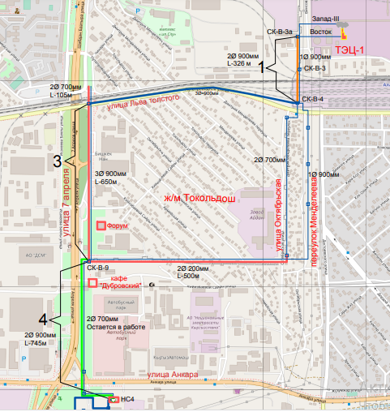

Appendix 2. Date of commissioning of the "Vostok" main heating network

Certificate on “Vostok main heating network from CK-B-3a and joint to Radiozavod from ZPZ-III to CK-B-9

- Site 1 from CK-B-3a to CK-B-4, the length is 326 m.
This Site is 2 DN 700 mm. Constructed in 1969.

- Site 3, the total length of existing route of Vostok pipeline without joint to Radiozavod is 1784 m. The Site from Oktyabrskaya street to CK-B-9 with the length of 500 m. This Site is 2 DN 700 mm, constructed in 1969 and 1 DN 900 mm, constructed in 1985.
Joint to Radiozavod from ZPZ-III to CK-B-9 with the length of 791 m 2 DN 700 mm, constructed in 1985.

- Site 4 from CK-B-9 to HC-4 with the length of 751 m.
This site is 1 DN 900 mm, constructed in 1985 and 2 DN700 mm, constructed in 2010.

Leading Engineer of the Capital Construction Dpt. Rybalkin P.V.

Appendix 3. Checklist of the social impact

№ | Possible impact | Accessibility (Yes/No) | Notes
1 | Will the project lead to the alienation of private land into private ownership? Will there be compulsory acquisition of land? | No
2 | Will the project have an impact on assets? | No
3 | Will the project impact trees (private and public)? | Yes | Seedlings will be planted in place of the uprooted trees at a rate of 3 to 1 after completion of construction works
4 | Is it necessary to physically or economically displace local residents or businesses? | No
5 | Is it necessary to determine the level of assessment of institutional resources needed for protection measures? | No
6 | Are there any third-party assets at the project site? | Yes | Upon completion of work, all objects will be restored and brought to their original state
7 | Are there territories in dispute? | No
8 | Will access roads and walkways be available to residential buildings and commercial structures during construction? | Yes
9 | Will the construction lead to changes in the social environment, and will the income of commercial structures and the population decrease? | No
10 | Will the planned construction affect public health and harm anyone? | No
11 | Will the project cause protests and anxiety among residents? | No
12 | Will the activity adversely affect people's living conditions, values, and lifestyles? | No
13 | Will the project cause inequality between population groups? | No
14 | Is there a high degree of public interest to the project? | Yes
15 | Are there any facts of past involuntary resettlement impacts in the area that require corrective action for unmitigated past resettlements? | No
16 | Is this project related to any other infrastructure development project? | No

Jumaliev K.B.
Environment and social consultant
Signature:

Date: 11.11.2022.

Appendix 4. Technological agreements

Technological Agreement
The Kyrgyz Republic, Bishkek city
Second of October of two thousand nineteen

OJSC “Bishkekteploset”, represented by the First dty. General Manager Mr. Dagai Yan V., acting on the basis of the Power of Attorney No. 104/2258-19 dtd. 27.09.2019, hereinafter referred as “Party 1” and “Dubrovskiy” restaurant, represented by Mr. Serkov V.V. hereinafter referred as “Party 2”, together named “the Parties”, concluded this technological agreement about below mentioned:
- The Parties of this technological agreement, understanding and admitting the importance of implementation of works for reconstruction of heat supply network which provides heat supply for 450 apartment houses (more than 70 000 households) and around 29 public buildings (schools, kindergartens, hospitals) located in the south part of Bishkek city, agreed about close cooperation and assistance during implementation of the project by “Party 1”.
- In execution of this agreement, hoping for successful cooperation in resolving technological issues, the Parties undertake to make every effort to avoid any future disputes or property claims.
- In order to cooperate and exclude any obstacles in the implementation of works by Party 1, Party 2, upon receipt of written notice of the beginning of repair work, undertakes to provide unimpeded access for the period of work to carry out repair and maintenance work on heating networks. Also, Party 2, in case of technological necessity, undertakes to free its territory from movable objects (e.g. equipment, chairs, umbrellas, etc.) that may hinder the beginning of the repair work, including for the purpose of safe performance of work on the reconstruction of heating networks. All actions of Party 2 to free its territory for safe conduct of work are voluntary and exclude any property liability of Party 1, except for damage to Party 2's property caused by negligence or intent. Also, Party 2 undertakes not to make any additional claims or requirements for compensation of lost profits to Party 1 or third parties after completion of the work, except as provided for in this agreement.
- In turn, Party 1 undertakes to provide for the restoration of asphalt pavement, paving stones, lawns and other landscaping elements during the implementation of the repair work, as well as upon its completion during the excavation work. And also undertakes to provide measures to prevent complete blocking of the entrance part of the building, fire safety during gas flame and electric welding works on pipelines, including anti-damage measures during the works and to take all measures to prevent violations of the rights of Party 2 established by the legislation of the Kyrgyz Republic.
- Disputes and disagreements arising after the conclusion of this agreement, the Parties undertake to resolve by negotiation and conclusion of written agreements.
- The Parties have no collateral or additional terms and conditions to this agreement. This agreement is executed in two copies, one for each Party, each of which has the same legal force.

Party 1 Party 2
OJSC “Bishkekteploset” Restaurant “Dubrovkskiy”

Dagai Yan V.__(signed)___ ____(signed)________
(stamp)

Technological Agreement
The Kyrgyz Republic, Bishkek city
Second of October of two thousand nineteen

OJSC “Bishkekteploset”, represented by the First dty. General Manager Mr. Dagai Yan V., acting on the basis of the Power of Attorney No. 104/2258-19 dtd. 27.09.2019, hereinafter referred as “Party 1” and “Dasmiya” restaurant, represented by General Manager Mr. Mamashov Turusbek Ch. hereinafter referred as “Party 2”, together named “the Parties”, concluded this technological agreement about below mentioned:
- The Parties of this technological agreement, understanding and admitting the importance of implementation of works for reconstruction of heat supply network which provides heat supply for 450 apartment houses (more than 70 000 households) and around 29 public buildings (schools, kindergartens, hospitals) located in the south part of Bishkek city, agreed about close cooperation and assistance during implementation of the project by “Party 1”.
- In execution of this agreement, hoping for successful cooperation in resolving technological issues, the Parties undertake to make every effort to avoid any future disputes or property claims.
- In order to cooperate and exclude any obstacles in the implementation of works by Party 1, Party 2, upon receipt of written notice of the beginning of repair work, undertakes to provide unimpeded access for the period of work to carry out repair and maintenance work on heating networks. Also, Party 2, in case of technological necessity, undertakes to free its territory from movable objects (e.g. equipment, chairs, umbrellas, etc.) that may hinder the beginning of the repair work, including for the purpose of safe performance of work on the reconstruction of heating networks. All actions of Party 2 to free its territory for safe conduct of work are voluntary and exclude any property liability of Party 1, except for damage to Party 2's property caused by negligence or intent. Also, Party 2 undertakes not to make any additional claims or requirements for compensation of lost profits to Party 1 or third parties after completion of the work, except as provided for in this agreement.
- In turn, Party 1 undertakes to provide for the restoration of asphalt pavement, paving stones, lawns and other landscaping elements during the implementation of the repair work, as well as upon its completion during the excavation work. And also undertakes to provide measures to prevent complete blocking of the entrance part of the building, fire safety during gas flame and electric welding works on pipelines, including anti-damage measures during the works and to take all measures to prevent violations of the rights of Party 2 established by the legislation of the Kyrgyz Republic.
- Disputes and disagreements arising after the conclusion of this agreement, the Parties undertake to resolve by negotiation and conclusion of written agreements.
- The Parties have no collateral or additional terms and conditions to this agreement. This agreement is executed in two copies, one for each Party, each of which has the same legal force.

Party 1 Party 2
OJSC “Bishkekteploset” Restaurant “Dasmiya”

Dagai Yan V.__(signed)___ ____(signed)________
(stamp) (stamp)

Appendix 5. Extract from the contract for construction

“Procurement of works for reconstruction of the main section of heating network "Vostok" from СК-В-3а to PS№4 (I, III, IV - start-up facilities)
IDA/HSIP/ICB/W/2022

Bid documents, part 2, Requirements for works

When carrying out construction and installation works, environmental safeguards and requirements of the national legislation and regulations and requirements of the ESMPs should be observed.

Requirements of SNiP 3.05.03 Environmental protection shall be met when laying out heating networks. Heating network construction is not allowed without permit obtained according to established procedure. Washing of pipelines with reused water shall be implemented. Water from washing (disinfecting) pipelines shall be discharged into areas set forth in Work performance plan.
Upon completion of heating network installation, the area shall be cleaned from construction debris and refurbished as required by the design. PU foam and PE thermal insulation debris shall be collected for further transportation and disposal in areas approved by State Sanitary and Epidemiological Supervision in accordance with procedure of toxic industrial waste accumulation, transportation and disposal.

Bid documents, Appendix A to the Financial Part:
Items included in the statements should cover work, related equipment and materials, related costs of transportation, storage, disposal, labor (including applicable social and medical insurance), insurance, any possible costs associated with cramped urban conditions for work, other costs - depending on each item.
The financing of facilities is subject to value added tax in accordance with the tax code.

Appendix 6. Screening photos

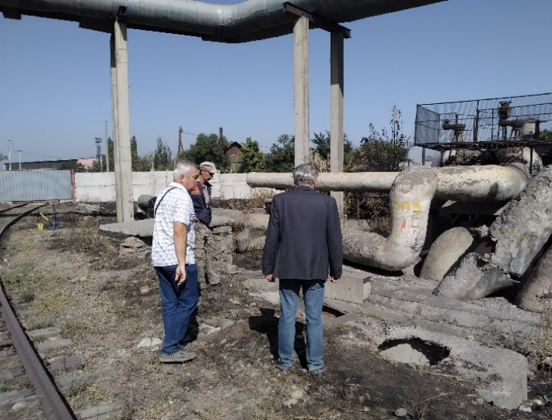
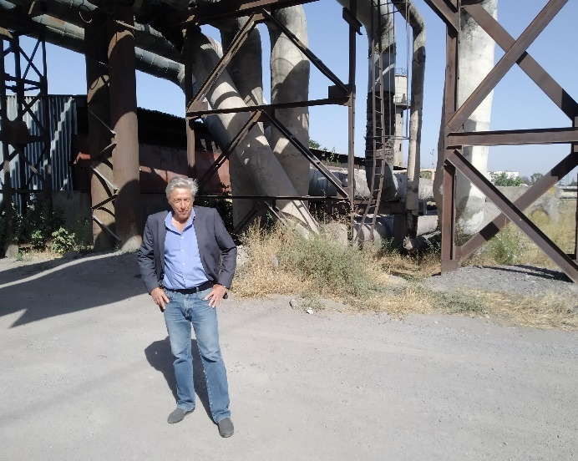
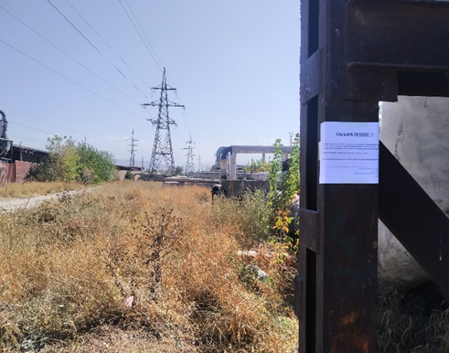
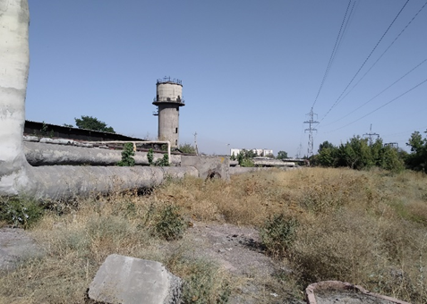
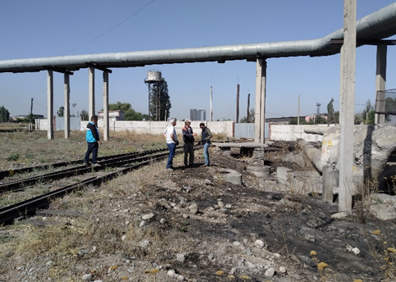
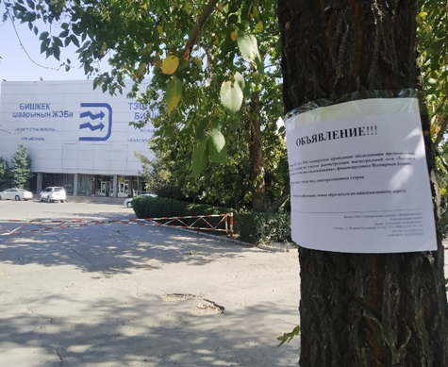
Ist start-up facility
Announcement on the site
Announcement on the site
Heating main line
CK-B-3

Heating main line
CK-B-3a

Heating main line
CK-B-4

Heating main line
CK-B-3

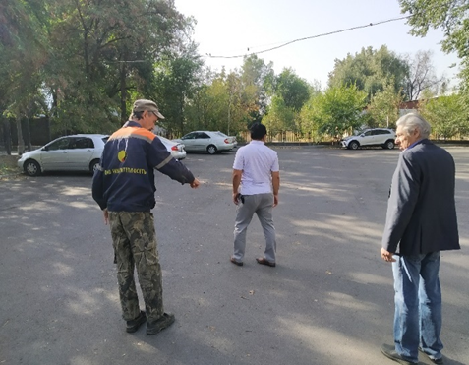
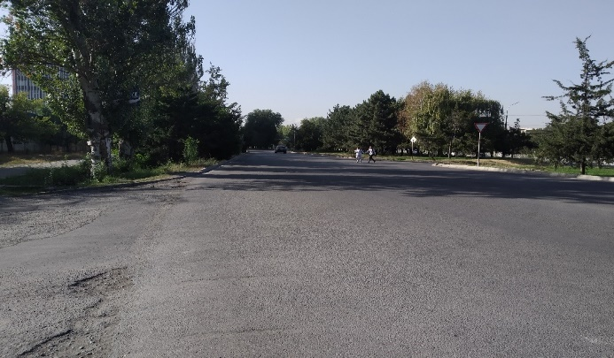
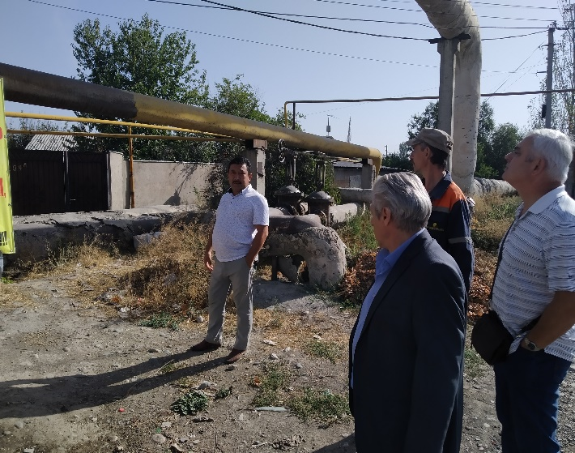
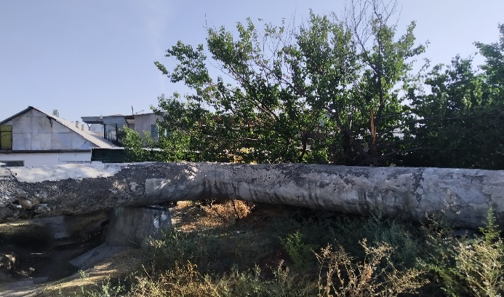
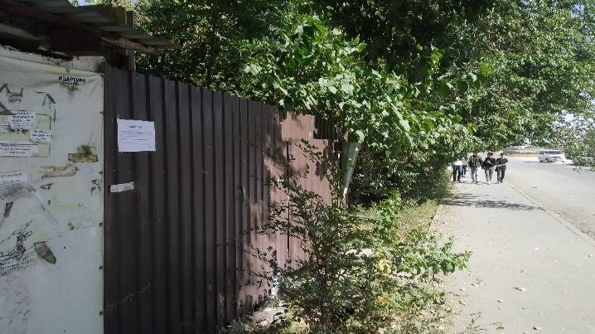
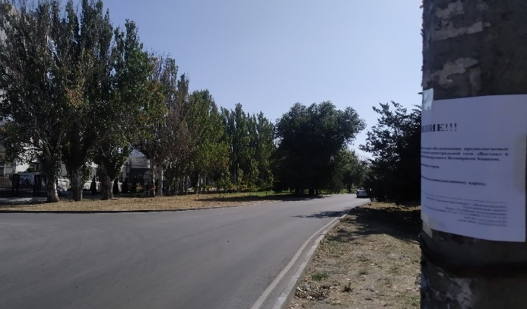
IIIrd start-up facility
Announcement on the site
Announcement on the site
Over-ground pipeline
Thermal chamber CK-B-8
Over-ground pipeline
Thermal chamber CK-B-8
Heating main line
Parking lot
OJSC "Bishkek NAN"
Other access road

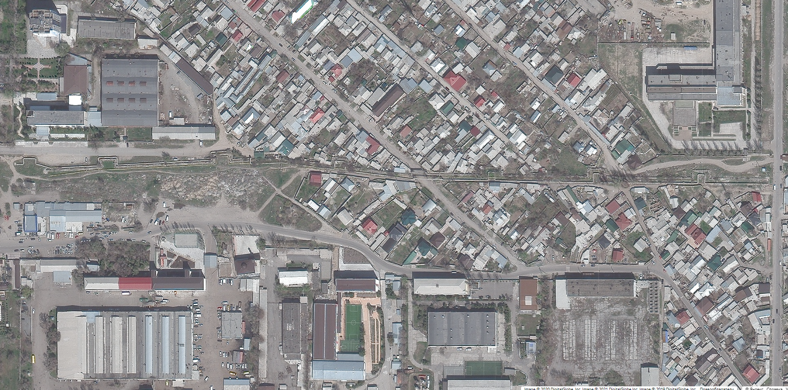
CK-B-8
CK-B-9
Over-ground pipeline
Site to from Thermal chamber CK-B-9 to Thermal chamber CK-B-8
Length of the route is 500 m.

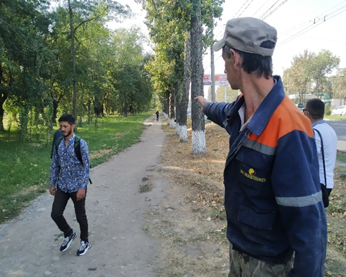
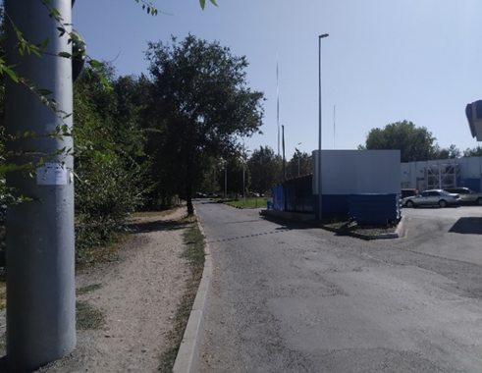
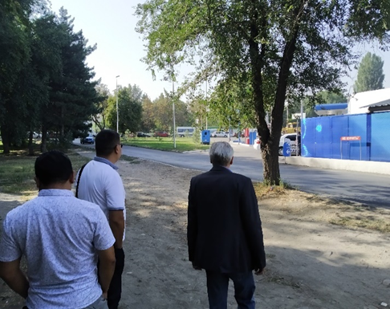
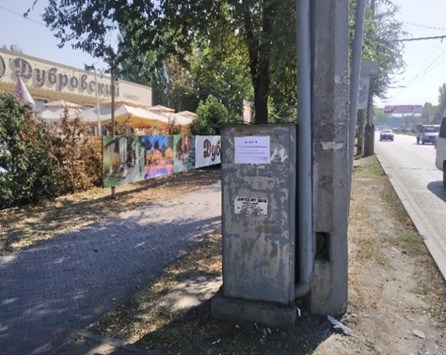
IVth start-up facility

Heating main line"

"Dubrovskiy" Cafe

Heating main line"

"Gazprom Neft Asia" LLC

Heating main line
Heating main line"
"Gazprom Neft Asia" LLC
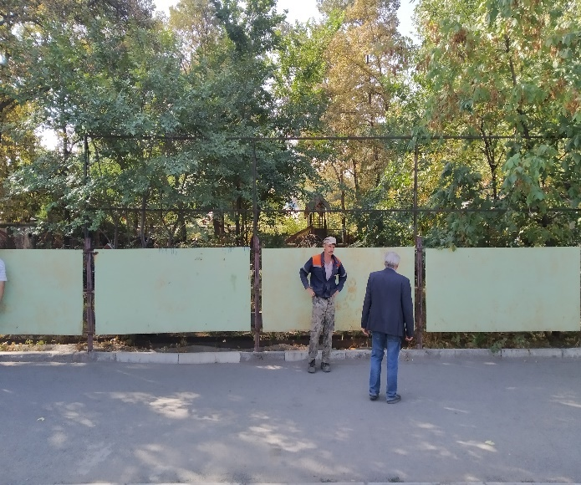
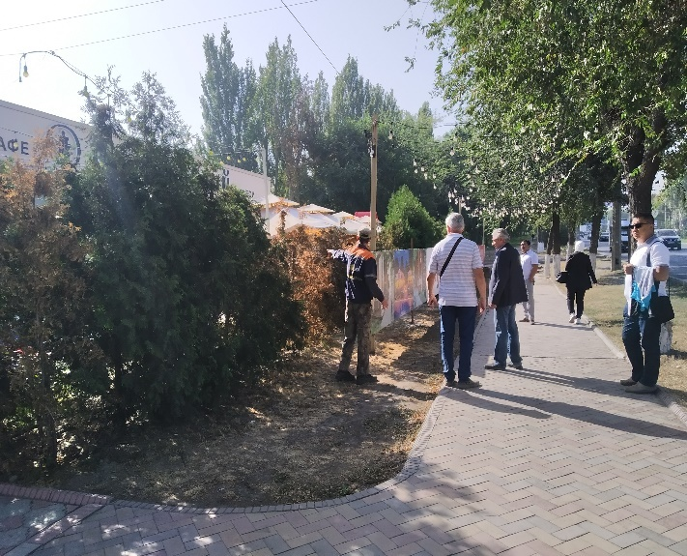
Announcement on the site
Announcement on the site

Appendix 7. Operational norms

Approved by order of the Gosstroy of Russia

December 13, 2000 No. 285

OPERATION OF HEAT NETWORKS

Operation of thermal networks

BTS during operation:

Maintain pipelines and equipment, building and other structures of heating networks in good condition, checking and repairing them;

observe the operation of compensators, supports, fittings, drains, instrumentation and other elements, detect defects in a timely manner;

the need to remove air from heat pipelines, limit excess pressure at all points of networks and sources of heat consumption;

observe cleanliness in the chambers and channels, prevent their presence by unauthorized persons;

research on the control of the state of France and anti-corrosion coverage using modern instruments and diagnostic methods, as well as research, research and other methods;

keep a record of all damages and identified defects for all types of equipment and analyze the causes that caused them.

The frequency and scope of work to supervise the state of the network by the main technical supervision of the organization.

During the operation of heat networks and heat purposes, possible types of work should be performed:

Maintenance;

scheduled repairs (current and capital);

emergency recovery work;

withdrawal of equipment into reserve or conservation and commissioning from reserve, repair or conservation.

Appendix 8. Summary of individual consultations

Summary of individual consultations for Heat supply improvement project

Place: Bishkek city (Start-up facilities 1, 3 and 4)

Date: 20.12.2022, 10:00-15:30

Individual consultations were held in order to follow environmental and social standards of the World Bank and national legislation of the Kyrgyz Republic as well as to inform stakeholders about main objectives of the Heat supply improvement project.

Possible negative impacts of the project activities on the environment and social environment, as well as the proposed preventive measures to mitigate them in order to prevent and/or minimize the expected negative effects.
Heat supply improvement project is financed by the World Bank.

Project budget: 31 million USD.

Project implementation period: 2019-2023.

Agenda:

Discussion on the Environmental and Social Management Framework Document (ESMF), Resettlement Policy Framework (RPF), Environmental and Social Management Plans (ESMP), Grievance Redress Mechanism (GRM) prepared for the Heat Supply Improvement Project.

Following stakeholders participated in individual consultations:

Representatives of “Gazprom” gas station, “SHNOS” gas station, “Ekdan” LLC, International University of Kyrgyzstan, OJSC “Bishkek NAN”, OJSC “Media Forum”, “Dubrovskiy” café, “Dasmiya” café.

Specialists of BTS:

Chief of the Capital Construction Dpt. – Ryspaev K.K.
Chief of Legal Dpt. – Saifudinov A.B.
Dty. Chief of the Central district – Fyonov P.V.

Specialists of BTS PIU:

Leading Engineer of the Capital Construction Dpt. – Rybalkin P.V.
Environment and Social Consultant – Jumaliev K.
14 persons participated in consultations. Registration list is attached.

Chairman:

Ryspaev K.K. – Chief of the capital construction dpt. Of the branch of OJSC “Power Plants” – “Bishkekteploset”

Ryspaev K.K. greeted each of the participants in the individual consultations. Afterwards, he familiarized all the participants with the "Improvement of Heat Supply" project financed by the World Bank. Introduced the project objectives, components, planned activities, project budget and implementation mechanisms.

Jumaliev K. informed participants about objectives of the individual consultations. All participants may ask actual questions, give comments and proposals.
He acquainted the participants of the consultations with the prepared and agreed documents for this project. Environmental and Social Management Framework Document (ESMF) which can be found on the website by the following link http://www.teploseti.kg/content/articles_view/895. Resettlement Policy Framework (RPF) - https://teploseti.kg/content/articles_view/895, Environmental and Social Management Plans (ESMP) which are prepared separately for each Site and can be found on the website http://www.teploseti.kg/content/articles_view/1389, Grievance Redress Mechanism (GRM) which is approved and allocated on the website https://teploseti.kg/uploads/download/34a8569a825e8909d15b67f6bf57e021.pdf, the objective of which is registration and consideration of any grievances which can occur during project implementation stage, and/or any future operational problems, which can be solved during implementation. The World Bank's environmental and social standards, the possible environmental and social impacts of project activities, and the measures being taken to prevent and/or minimize the expected negative impacts were covered in detail. He noted that the World Bank pays great attention to compliance with environmental and social standards, which detail environmental and social risks, the effects of involuntary resettlement and access restrictions, gender-based violence, child labor, health, safety and security in construction work, and accessibility and disclosure to all stakeholders.

Participants then moved on to questions and vigorous discussion:

Question 1.
What is the timeline and budget for this project?
Answer 1. Jumaliev K.
Implementation project timeline is 2019-2023, project budget – 11 million USD.

Question 2.
What will happen to our lot where we have a lawn and a sprinkler system installed?
Answer 2. Jumaliev K.
Everything will be dismantled before construction work begins. Everything will be restored by a Contractor after the construction work. This issue will be included in the contract.

Question 3.
When do you plan to start construction works and will you meet the deadline?
Answer 3. Ryspaev K.K.
Planned commencement date is March, 2023. Of course we will make all efforts in order to complete all works within timeline.

Question 4.
How will access to our facility be ensured during construction work?
Answer 4. Jumaliev K.
Do not worry, because you have two entrances to your company, access will be ensured from either one side or the other.

Question 5.
Who will carry out construction works?
Answer 5. Rybalkin P.V.
Tender was announced for implementation of construction works. The most qualified company to carry out construction works will be selected according to the results of the tender.

Question 6.
Will you notify us in advance before starting construction works?
Answer 6. Ryspaev K.K.
Of course, there will be official notification before the start of construction works.

Question 7.
As far as I understand, the parking lot will be destroyed. Who will restore the parking lot after the construction work and will access to the building be ensured?
Answer 7. Jumaliev K.
Since the existing main heating network runs under the parking lot, we will have to partially destroy the asphalt surface of the parking lot. Also, fences will be temporarily removed. All will be restored after completion of the construction works by a Contractor. As for access to the building, access will be provided by installing portable bridges for the duration of construction works.

Question 8.
What is the duration of construction works?
Answer 8. Rybalkin P.V.
Planned commencement date is March 2023, planned completion date is October 2023. We need to complete before the heating season starts.

Question 9.
What will happen to our territory, to fences, lightweight structures?
Answer 9. Jumaliev K.
Everything will be neatly dismantled and stacked before construction work begins. After the completion of construction works, everything will be restored by the contracting company. The restoration work will be included in the contract of the contracting company.

Question 10.
Who will ensure quality of works?
Answer 10. Rybalkin P.V.
It is planned to select a company for technical supervision in order to ensure quality of works. Also design company will carry out design supervision. BTS PIU team will carry out a regular supervision.

Ryspaev K.K. thanked everyone for their active participation and expressed hope that all activities will be carried out qualitatively and on time. He noted that social and environmental standards of the World Bank and legislation of the Kyrgyz Republic shall be followed during implementation of the project.

Secretary of the meeting:

Jumaliev K.B.
Environmental and Social Consultant
Signature:
Date: 20.12. 2022.

Bishkekteploset (BTS) was merged into Electric Power Plants (EPP) in July 2022, and EPP has become the legal successor of all obligations of BTS under Financial Agreement, Subsidiary Agreement and Project Agreement of the HSIP.
http://teploseti.kg/content/articles_view/895
http://teploseti.kg/content/articles_view/895
Implementing Agency for the Component 1 which became a branch of the EPP as indicated above.
http://teploseti.kg/content/articles_view/1389
http://teploseti.kg/content/page/76
http://teploseti.kg/content/articles_view/895
https://teploseti.kg/content/articles_view/1512
https://teploseti.kg/uploads/download/34a8569a825e8909d15b67f6bf57e021.pdf

